**DAILY ONLINE ACTIVITIES SUMMARY**

|  |  |  |  |  |  |  |  |  |
| --- | --- | --- | --- | --- | --- | --- | --- | --- |
| Date: | 28/05/2000 | | | | | Name: | Jyothi B R | |
| Sem & Sec | IV-A | | | | | USN: | 4AL18CS030 | |
| Online Test Summary | | | | | | | | |
| Subject | | Microprocessor and Microcontroller Embedded System , Adalitha Kannada | | | | | | |
| Max. Marks | | 20 ,50 | | Score | | | 20 ,32 | |
| Certification Course Summary | | | | | | | | |
| Course | Programming Essentials in Python | | | | | | | |
| Certificate Provider | | | Cisco Virtual Academy | | Duration | | | 2.5hrs |
| Coding Challenges | | | | | | | | |
| Problem Statement. 1.Sub-array using python  2. A digital root is the recursive sum of all the digits in a number | | | | | | | | |
| Status:Completed | | | | | | | | |
| Uploaded the report in Github | | | | | Yes | | | |
| If yes Repository name | | | | | https://github.com/alvas-education-foundation/jyothi_b_r | | | |
| Uploaded the report in slack | | | | | Yes | | | |

Online Test Details: (Attach the snapshot and briefly write the report for the same)

Certification Course Details: (Attach the snapshot and briefly write the report for the same)

Coding Challenges Details: (Attach the snapshot and briefly write the report for the same)

ONLINE TEST DETAILS:

1.Micro-process and Microcontroller Embedded System:

The online test was from module 2. There were 20 questions which contains 20 mcq questions and the duration were 40 minutes. The questions were optimal and easy. The score that I received was 20/20.

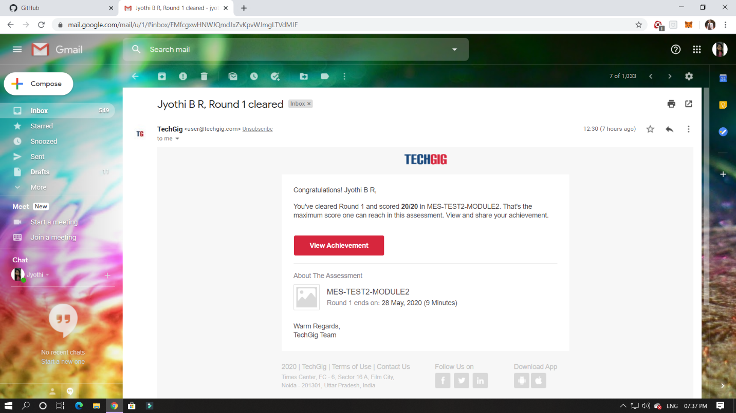

2.Adalitha Kannada:

The online test was from all the 10 chapters. There were 50 questions which contains 50 mcq questions and the duration were 50 minutes. The questions were optimal. The score that I received was 32/50.

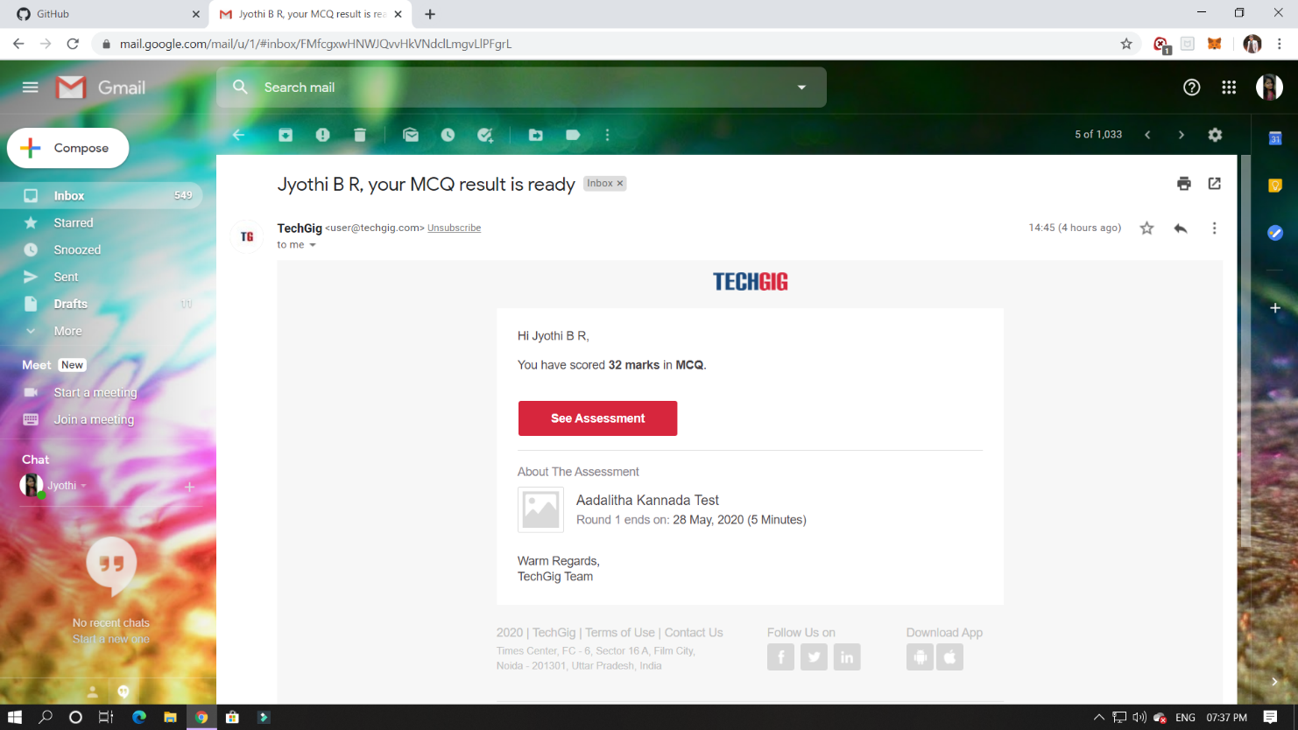

CERTIFICATION COURSE DETAILS:

Programming Essentials in Python :

**Parametrized functions**

The function's full power reveals itself when it can be equipped with an interface that is able to accept data provided by the invoker. Such data can modify the function's behavior, making it more flexible and adaptable to changing conditions.

In this class it says about how to define the function and parameters. Which is used to initialise the value inside and outside the parantheses.

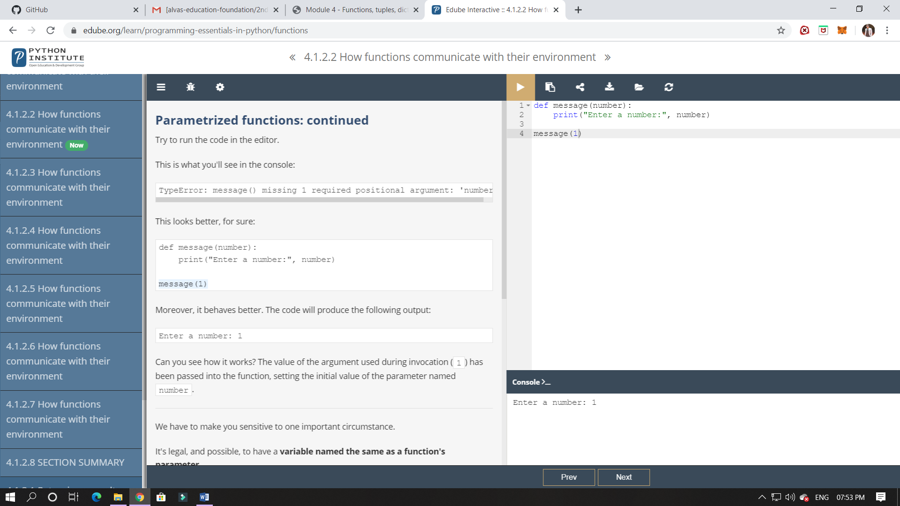

ONLINE CODING:

**1. In an array X of size M where the array elements contain values from 1 to M with duplicates, the task is to find total number of sub arrays which start and end with the same element.**

|  |
| --- |
|  |

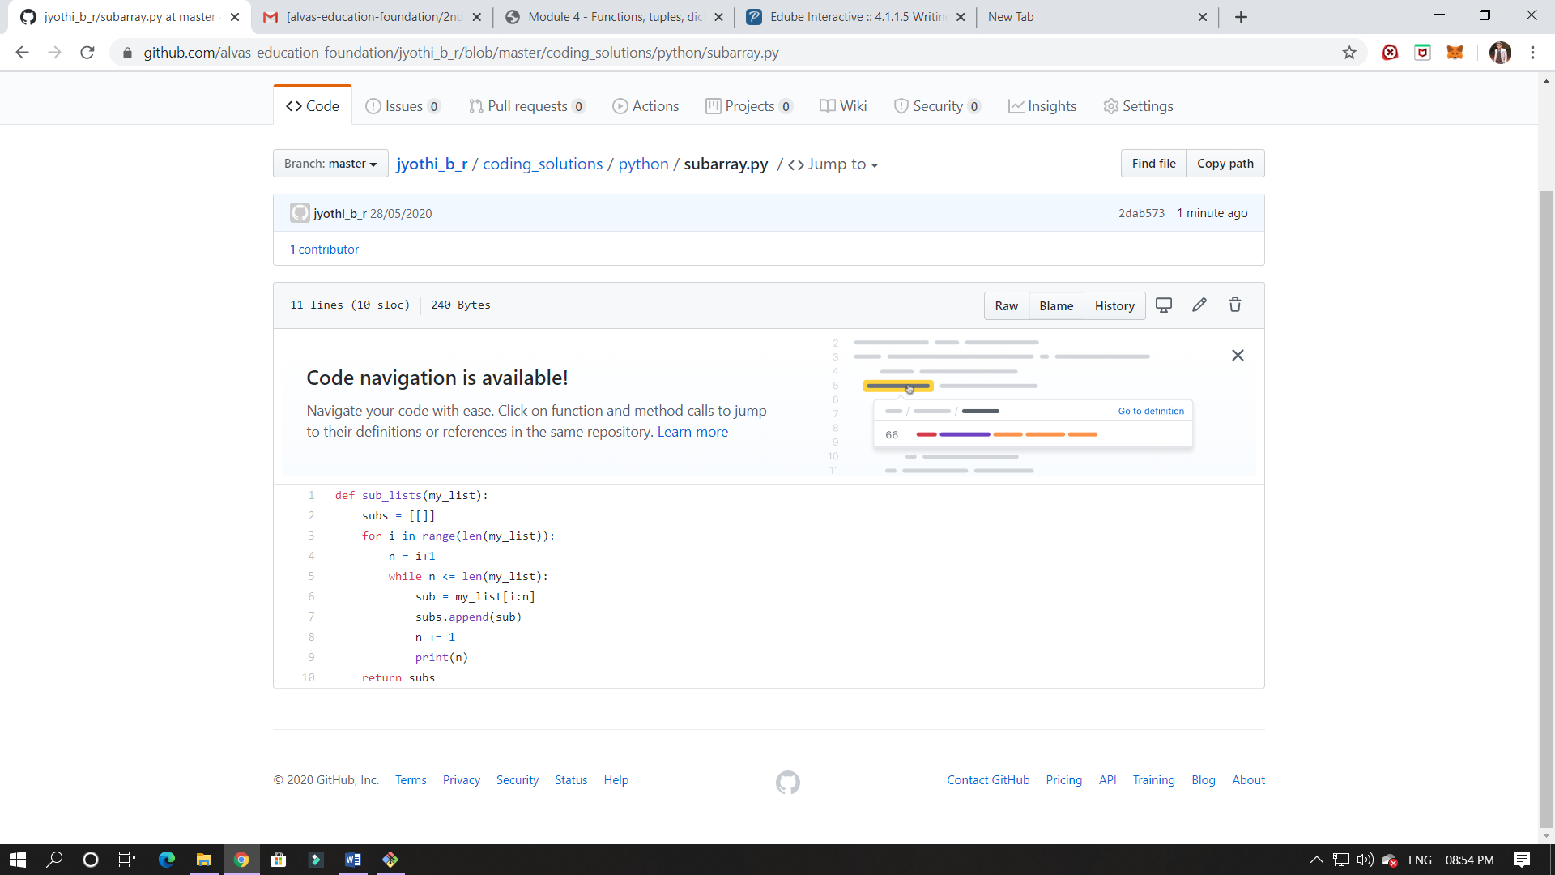

2. A digital root is the recursive sum of all the digits in a number. Given n, take the sum of the digits of n. If that value has more than one digit, continue reducing in this way until a single-digit number is produced. This is only applicable to the natural numbers.

